One man rescue operation on a burning ship

19th March 1943: George Stronach awarded George Cross after he ignores the fires on the Ocean Voyager - loaded with petrol and ammunition - and saves many lives
MAR 19

SAVE |  | ▷ LISTEN

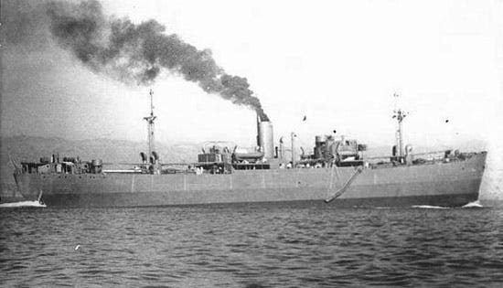
The Ocean Vanguard, sister ship of the Ocean Voyager. Sixty Ocean class 7,174 GRT ‘Liberty’ ships were built for the British in America in 1941-1942.
The war over the supply lines across the Mediterranean was fought just as fiercely as the land battles in North Africa. The Royal Navy was stretched to the limit in its attempt to protect Allied convoys coming in from the Atlantic and attack Axis convoys crossing the Mediterranean.
In the line of fire were the Merchant Marine and Merchant Navy who risked being torpedoed, bombed or mined whether in convoy or not. Just maintaining a shipping service required courage from every seaman.
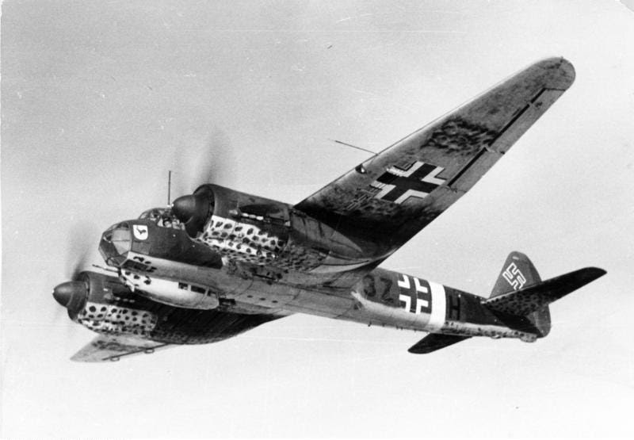
Junkers Ju.88 from KG 77 (North Africa/Italy).
On 19 March 1943, the merchant vessel SS Ocean Voyager was lying off Tripoli unloading a large consignment of petrol drums and ammunition. A group of Luftwaffe Ju 88 bombers made a surprise attack at about 18.45, flying in low to avoid detection.
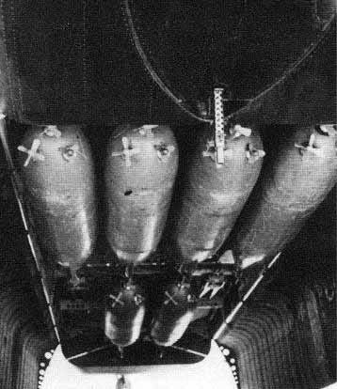
The Motorbomba FFF carried a 120 kilograms (260 lb) warhead.
They were making the first German use of Italian Motobomba FFF torpedoes. These were regarded as among the most sophisticated weapons of their type. Dropped by parachute, they were driven at 40mph in a concentric spiral expanding from 500m to 4000m metres until they hit a target or the electric batteries were exhausted - between 15-30 minutes. The Allies were very keen to get their hands on an example.
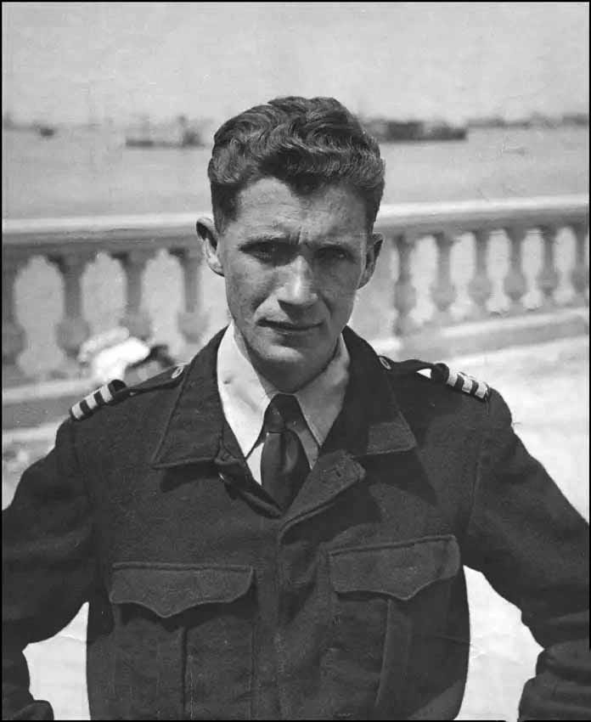
George Stronach (1912-1999) was twenty-eight at the time. He doused himself in water to protect himself as best he could from the flames. After recovering from his wounds, he returned to the sea. After the war he became a pilot on the Clyde, retiring in 1979.
The SS Ocean Voyager was probably hit by two torpedoes as well as a conventional bomb which hit the bridge. The Master, Captain Duncan MacKellar, was killed and the Chief Officer, George Stronach, was knocked unconscious. Regaining consciousness, Stronach found himself on a burning ship with ammunition burning off, liable to erupt in a massive explosion at any moment.
Second Engineer H. Hotham made would later recall:
Fierce fires were raging in every part of the ship … The accommodation amidships was completely wrecked and blazing furiously, whilst the bridge was a shambles.
I asked the Chief Officer where everyone was and he said that the majority of the crew had jumped overboard … I subsequently learnt that he had gone aft and persuaded a number of the elderly sailors and firemen to follow him to the ship’s motor lifeboat. These men were cowering in the foc’sle alleyway, sheltering from the flying debris and were too petrified with fear to move until the Chief Officer led them away to the lifeboat.
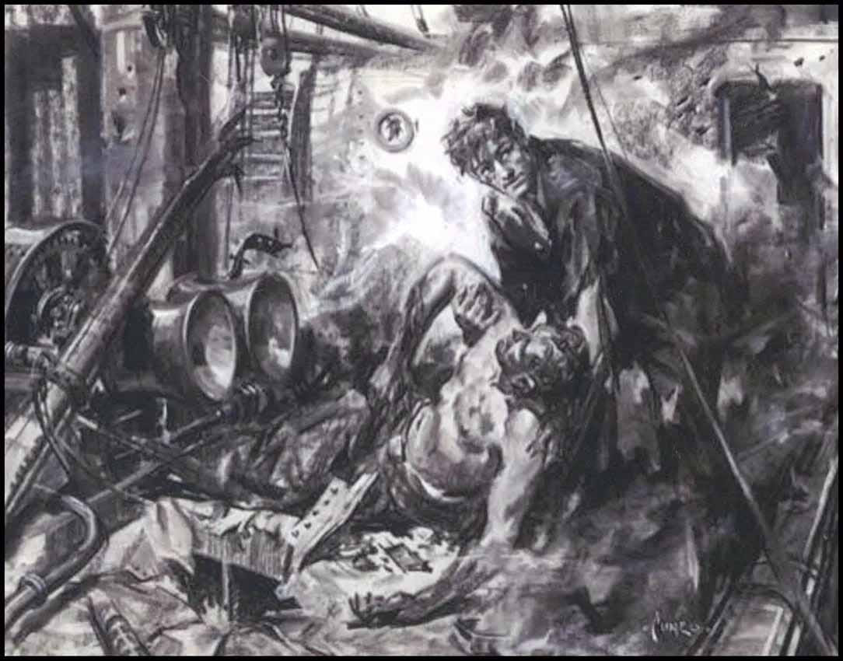
A subsequent artist’s impression of George Stronach on the Ocean voyager.
Exceptional acts of bravery away from the battlefield were now recognised. King George had introduced the George Cross during the Blitz "for acts of the greatest heroism or for most conspicuous courage in circumstance of extreme danger" not in the presence of the enemy. The George Cross has the same standing as the Victoria Cross.
In the full knowledge that she was likely to blow up at any moment Chief Officer Stronach stayed on this burning vessel searching for survivors for an hour and twenty minutes.
The KING¹ has been graciously pleased to award the GEORGE CROSS to: — George Preston Stronach, Esq., Chief Officer
When the ship was lying in harbour, a severe aircraft attack developed and she was hit and at once caught fire. The vessel had a large consignment of petrol and ammunition on board, which was exploding heavily all the time and in spite of strenuous efforts which were made to fight the fire she had to be abandoned.
The Master was killed by the explosion and the responsibility for further operations devolved on the Chief Officer. He had been rendered temporarily unconscious but recovered almost immediately and went forward to look for survivors.
He found a number of the crew sheltering in the alley way and, braving the exploding ammunition, led them to a boat alongside which took them to safety. In order to provide for the transport of any other survivors who might be found, he then lowered another boat and brought it alongside the ship.
Although the vessel was now burning furiously Mr Stronach made his way to the officers' accommodation amidships. Finding a hose with a trickle of water coming through, he held this over his head and so kept himself sufficiently wet to protect him from the worst of the heat and flames.
… taking a final look round aft, he saw a greaser lying unconscious in the scuppers. He dragged this man to the side of the ship, but finding there was no raft or boat alongside, put a lifebelt around him and threw him overboard.
With great difficulty he climbed into the collapsed accommodation and found one of the deck officers, unconscious and badly burned. Mr. Stronach pulled him clear and dragged him along the deck to the lowered boat. Returning to the accommodation, he began to remove the debris from another officer who was trapped. By almost superhuman efforts he dragged the man through the porthole and along the deck.
He then tied a rope around his waist and lowered him over the side to the boat. As the situation was becoming desperate Mr Stronach ordered a man to take the boat to safety and once again he returned amidships where he discovered an officer who had been severely injured. Dragging him along the deck to the side of the ship, he tied a rope around him and lowered him over the side on to a raft which had returned to the ship in response to his calls.
Again Mr. Stronach continued his search for survivors and, taking a final look round aft, he saw a greaser lying unconscious in the scuppers. He dragged this man to the side of the ship, but finding there was no raft or boat alongside, put a lifebelt around him and threw him overboard.
When he was satisfied that there were no further survivors the Chief Officer jumped overboard and swam to a raft which, under his direction, returned to pick up the injured greaser.
In the full knowledge that she was likely to blow up at any moment Chief Officer Stronach stayed on this burning vessel searching for survivors for an hour and twenty minutes. His inspiring leadership induced a number of the crew to get away and so saved their lives and by his gallant efforts, undertaken with utter disregard of his personal safety, he saved the lives of three officers and a greaser, all of whom were badly hurt.
His action equals any in the annals of the Merchant Navy for great and unselfish heroism and determination in the face of overwhelming odds.
1
London Gazette 23 November 1943

